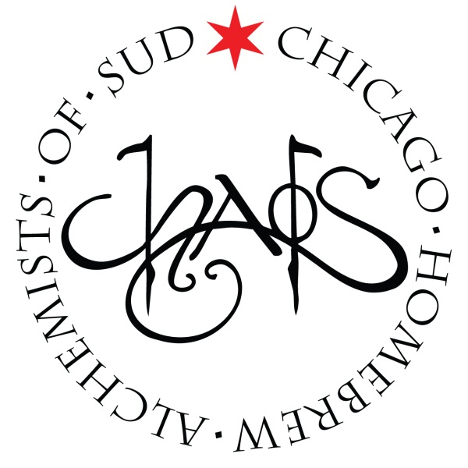
CHAOS Brew Club
August Board of Directors Meeting
Sunday – 8/3/2014 – 4:30PM
- Call to order
- Roll call
- Approval of minutes from 7/6/2014
- Committee Reports
  - Finance – Mark Walters
  - Membership – Jim Chochola
  - Brew House – Chuck Mac
  - Education – Matt Omura
  - Website – Lucas Morris
  - Public Relations – Jamie Proctor
  - Events – Steven Lane
  - Legal – Ken Getty
  - Quarterly Events:
    - Summer Brew-B-Q (August 9, 2014) – Jamie Proctor
    - Harvest Fest (October 18, 2014) – Conrad Fuhrman & Jeff Whelpley
    - Stout Night (January 24, 2015) –
- Old Business
  - Inventory Asset Control – Mark Walters
- New business
  - New Committee Report Structure
- Upcoming Scheduled Events & Meetings:
  - Tuesday Brews Day - TURBID MASH DEMO - (CHAOS Brewhouse) – August 5th: 6:30PM-11:00PM
  - Open Mic-ro Night (Beermiscous, 2812 N. Lincoln Ave.) – August 7th: 6:00pm-9:00pm
  - Summer Brew-BQ II (CHAOS Brewhouse) – August 9th: 6pm to11pm
  - Omega Yeast Workshop (CHAOS Brewhouse) – August 14th: 7pm to10pm
  - CHAOS Open House (CHAOS Brewhouse) – August 16th: 10:00AM-3:00PM
  - CHAOS BYOB Dinner (Blue Frog’s Local 22, 22 E Hubbard St) –August 22nd: 7:00pm to 10:00pm
  - Board of Directors - (CHAOS Brewhouse) – September 7th: 4:30PM-6:00pm
  - Monthly Meeting - (CHAOS Brewhouse) – September 7th: 6:30PM-8PM
  - Tuesday Brews Day (CHAOS Brewhouse) – September 9th: 6:30PM-11:00PM
  - CHAOS Open House (CHAOS Brewhouse) – September 13th: 10:00AM-3PM
  - CHAOS Family BBQ & Bottle Share (CHAOS Brewhouse) – October 4th: 11:00AM-3:00PM
  - Board of Directors - (CHAOS Brewhouse) – October 5th: 4:30PM-6:00pm
  - Monthly Meeting - (CHAOS Brewhouse) – October 5th: 6:30PM-8PM
  - CHAOS Open House (CHAOS Brewhouse) – October 11th: 10:00AM-3:00PM
  - Harvest Fest (CHAOS Brewhouse) – October 18th: 6:00PM-11:00PM
  - Stout Night (CHAOS Brewhouse ) - January 24, 2015: 6:00PM-11:00PM
- President’s Report – Ken Getty
- Adjournment

