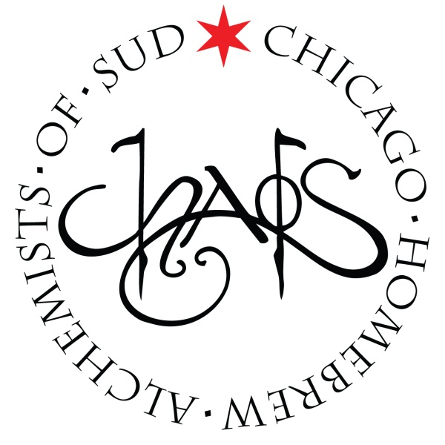
CHAOS Brew Club
August General Meeting
Sunday – 8/3/2014 – 6:00PM
- Call to order
- Old Business
  - Barrel Watch – Kyle Arnold & Josh Smith
  - July’s Podcast-a-Palooza (Fuhmentaboudit & ABV Chicago) – Ken Getty
  - AHA Rally – Ken Getty
  - July’s Hoppy Hour & Tuesday Brewsday – Josh Smith & Jim Chochola
- New Business
  - Summer Cleaning & Build Date?
- Announcements:
  - Final Call for Volunteers
  - Start brewing about your Stout Recipes for Stout Night on January, 24, 2015
- Upcoming Scheduled Events & Meetings:
  - Tuesday Brews Day - TURBID MASH DEMO - (CHAOS Brewhouse) – August 5th: 6:30PM-11:00PM
  - Open Mic-ro Night (Beermiscous, 2812 N. Lincoln Ave.) – August 7th: 6:00pm-9:00pm
  - Summer Brew-BQ II (CHAOS Brewhouse) – August 9th: 6pm to11pm
  - Omega Yeast Workshop (CHAOS Brewhouse) – August 14th: 7pm to10pm
  - CHAOS Open House (CHAOS Brewhouse) – August 16th: 10:00AM-3:00PM
  - CHAOS BYOB Dinner (Blue Frog’s Local 22, 22 E Hubbard St) –August 22nd: 7:00pm to 10:00pm
  - Board of Directors - (CHAOS Brewhouse) – September 7th: 4:30PM-6:00pm
  - Monthly Meeting - (CHAOS Brewhouse) – September 7th: 6:30PM-8PM
  - Tuesday Brews Day (CHAOS Brewhouse) – September 9th: 6:30PM-11:00PM
  - CHAOS Open House (CHAOS Brewhouse) – September 13th: 10:00AM-3PM
  - CHAOS Family BBQ & Bottle Share (CHAOS Brewhouse) – October 4th: 11:00AM-3:00PM
  - Board of Directors - (CHAOS Brewhouse) – October 5th: 4:30PM-6:00pm
  - Monthly Meeting - (CHAOS Brewhouse) – October 5th: 6:30PM-8PM
  - CHAOS Open House (CHAOS Brewhouse) – October 11th: 10:00AM-3:00PM
  - Harvest Fest (CHAOS Brewhouse) – October 18th: 6:00PM-11:00PM
  - Stout Night (CHAOS Brewhouse ) - January 24, 2015: 6:00PM-11:00PM
- President’s Report – Ken Getty
- Adjournment

