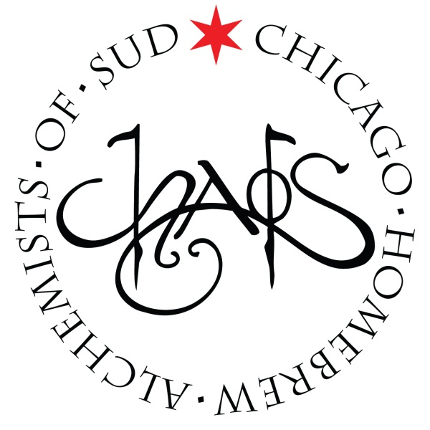
CHAOS Brew Club
October General Meeting
Sunday – 10/5/2014 – 6:00PM
- Call to order
- Old Business:
  - Barrel Watch –Josh Smith
- New Business:
  - Secret Santa Bottle Share Sign-Up will be going out this week!
- Announcements:
  - CONGRATS TO DAVID WILLIAMS!!! – Bronze Medal at GABF for his Horse Thief Hollow 18th Rebellion (Zicklebier)
  - Nielsen Massey Homebrew Competition – DEADLINE IS TONIGHT!
    - See Jeff Whelpley for Extract
- Upcoming Scheduled Events & Meetings:
  - Nielsen Massey Homebrew Registration Deadline – October 5th: online
  - Hoppy Hour: Horse Thief Hollow (10426 S. Western Ave, Chicago, IL 60643) – October 7th : 7:00pm-10:00pm
  - Beer Hoptacular (Aragon Ballroom) - October 10 & 11th: Three Sessions
  - CHAOS Open House – October 11th: 10:00AM-3:00PM
  - Tuesday Brews Day: TBD – October 14th: 6:30pm-11:00pm
  - Harvest Fest – October 18th: 6:00PM-11:00PM
  - American Homebrewing Association Rally (Lagunitas Tap Room) – October 19th: 1:00pm-4:00pm
  - CHAOS Workshop: Recipe Formulation with Randy Mosher – October 21st: 6:30PM-9:00PM
  - Learn to Homebrew Day – November 1st: Stay Tuned for Schedule
  - Board of Directors – November 2nd: 4:30PM-6:00pm
  - Monthly Meeting - November 2nd: 6:30PM-8PM
  - Tuesday Brews Day: TBD – November 11th: 6:30pm-11:00pm
  - BYOB Dinner: TBD – November 19th: 6:30PM-8:30PM
  - Chicago Bears Hoppy Hour: TBD – December 4th: 7:00PM-10:30PM
  - CHAOS Secret Santa & Holiday Bottle Share – December 6th: 7:00pm-12:00am
- President’s Report – Ken Getty (Absent – No Report)
- Adjournment & Introduction of Pat Berger of Paddy Long’s & Kasier Tiger

