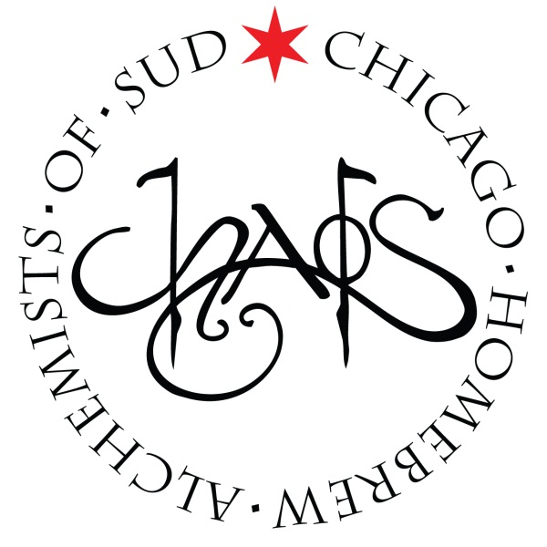
CHAOS Brew Club
September Board of Directors Meeting
Sunday – 9/7/2014 – 4:30PM
- Call to order
- Roll call:
Board Members: Conrad Fuhrman, Ken Getty, Steven Lane, Lucas Morris, Matt Omura, Jamie Proctor, Josh Smith, Jeff Whelpley, David Williams
Executive Officers: Ken Getty (President), Chuck Mac (Vice President), Mark Walters (Treasurer), Nancy Rockwood (Secretary), Jim Chochola (Membership), Matt Omura (Education)
- Approval of minutes from 7/6/2014 & 8/3/2014
- Committee Reports
  - Finance – Mark Walters
  - Membership – Jim Chochola
  - Brew House – Chuck Mac
  - Education – Matt Omura
  - Website – Lucas Morris
  - Public Relations – Jamie Proctor
  - Events – Steven Lane
  - Legal – Ken Getty (submitted via Forum)
  - Quarterly Events:
    - Harvest Fest (October 18, 2014) – Conrad Fuhrman & Jeff Whelpley
    - Stout Night (January 24, 2015) – Steven Lane
- Old Business
  - Inventory Asset Control – Mark Walters
  - PayPay & Stripe Website Error – Lucas Morris
- New business
  - Membership Audit – Lucas Morris & Mark Walters
  - Membership & Financial Forecast - Mark Walters
- Upcoming Scheduled Events & Meetings:
  - Tuesday Brews Day: Rye IPA – September 9th: 6:30PM-11:00PM
  - CHAOS Open House – September 13th: 10:00AM-3PM
  - CHAOS Workshop: Kegging 101 – September 25th: 7:00PM-9:00PM
  - Hoppy Hour: Fountainhead (1970 W. Montrose, Chicago, IL 60613) – September 30: 7:00pm-10:00pm
  - CHAOS Family BBQ & Bottle Share – October 4th: 11:00AM-3:00PM
  - Board of Directors - October 5th: 4:30PM-6:00pm
  - Monthly Meeting - October 5th: 6:30PM-8PM
  - Nielsen Massey Homebrew Registration Deadline – October 5th: online
  - Hoppy Hour: Horse Thief Hollow (10426 S. Western Ave, Chicago, IL 60643) – October 7th : 7:00pm-10:00pm
  - Beer Hoptacular (Aragon Ballroom) - October 10 & 11th: Three Sessions
  - CHAOS Open House – October 11th: 10:00AM-3:00PM
  - Tuesday Brews Day: TBD – October 14th: 6:30pm-11:00pm
  - Harvest Fest – October 18th: 6:00PM-11:00PM
  - CHAOS Workshop: Recipe Formulation with Randy Mosher – October 21st: 6:30PM-9:00PM
  - Learn to Homebrew Day – November 1st: Stay Tuned for Schedule
  - Board of Directors – November 2nd: 4:30PM-6:00pm
  - Monthly Meeting - November 2nd: 6:30PM-8PM
  - BYOB Dinner: TBD – November 14th: 6:30PM-8:30PM
- President’s Report – Ken Getty
- Adjournment

